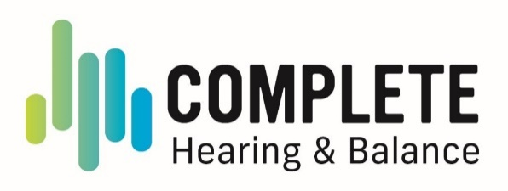
NOTICE OF PRIVACY PRACTICES
This notice describes how medical information about you may be used and discussed and how you can obtain access to this information.
Complete Hearing & Balance is committed to our patients “right to privacy.” All information regarding your condition, diagnosis or treatment is strictly confidential and will only be released with your written consent.
During your treatment at Complete Hearing & Balance, members of its staff may gather information about your medical history and your current health. The terms of this notice apply to the health information created or received by Complete Hearing & Balance. As our patient, you have entrusted us with your medical information. We know that your relationship with us is based on trust, and that you expect us to act in your best interests. As your personal medical history is your confidential information, we hold ourselves to the highest standards with its safekeeping.
The Health Insurance Portability & Accountability Act of 1996 ("HIPAA") is a federal program that requests that all medical records and other individually identifiable health information used or disclosed by us in any form, whether electronically, on paper, or orally are kept properly confidential. HIPAA provides penalties for covered entities that misuse personal health information. We are required by law to maintain the privacy of your protected healthcare information and to provide you with this notice of our legal duties and our privacy practices. HIPAA gives you, the patient, the right to understand and control how your protected health information ("PHI") is used.
Under HIPAA regulations, we may use and disclose your Protected Health Information (PHI) without written consent for treatment, payment, and health care operations (TPO).
Your medical information may be used and disclosed for the following purposes:
Treatment: We may use your information to provide, coordinate and manage your care and treatment. For example, a staff member may share your medical information with another health care provider for a consultation or referral. We will only disclose medical information to individuals assisting in your care to the extent permitted by law and after your written consent.
Payment: We may use and disclose medical information about you so that the treatment and services you received may be billed to and payment may be collected from you, an insurance company, or a third party.
Health Care Operations: We may use and disclose medical information about you for health care operations. Health care operations are the uses and disclosures of information that are necessary to make sure that all patients receive quality care. For example, we may use medical information to evaluate the performance of our staff in caring for you.
Appointment Reminders and other Health Information: We may use your medical information to send you reminders about future appointments. We may also contact you about new or alternative treatments.
Research and Marketing: Federal Law permits the usage and disclosure of medical information about you for research purposes, either with your specific written authorization, or as allowed by state law. In some cases, researchers may be permitted to use information in a limited way to determine whether potential participants are appropriate for research. If required to do so, we will obtain your consent before disclosure.
We will not use your information for marketing or fundraising. We will not sell your information. In compliance with federal and state privacy laws, written authorization by the patient or legal guardian is required before we can release records for reasons other than treatment, payment, and healthcare operations. If you authorize to release your records, you may revoke the authorization in writing, and we will honor your request from the date we receive your written request.
To Business Associates: Some services are provided by or to Complete Hearing & Balance through contracts with business associates. Examples include attorneys, consultants, collection agencies, and accreditation organizations. We may disclose information about you to our Business Associates so that they can perform the job for which we have contracted them to do.
Protecting Your Privacy Online: Our concern for your privacy naturally extends to our online communication. We transfer your data over the internet to submit health insurance claims via a secure server. We do NOT use Electronic Medical Records, so your chart is not accessible over the internet. We will file an insurance claim to your private insurance, Medicare, or supplemental insurance if you authorize us to do so. If you ask us not to give details about services to an insurance company that they will not cover, such as cosmetic services, we will honor your request.
You may have the following rights with respect to your PHI:
- The right to request restrictions on certain uses and disclosures of PHI, including those related to disclosures of family members, other relatives, close personal friends, or any other person identified by you. However, we are not required to honor restriction requests except in limited circumstances which we shall explain if you ask. If we do agree to the restriction, we must abide by it unless you notify us in writing.
- The right to advise us of the best location to contact you to protect your confidential information.
- The right to send a written request for a copy of your medical record.
We will notify you if a breach of your protected health information occurs. You can request an amendment of your PHI. This request must be done in writing and will be honored at our discretion. We will maintain a log of disclosures of your medical information for the past six years and you can request a copy.
Please tell us if you feel our office has violated your protection. You have the right to file a formal, written complaint with our practice and with the Department of Health and Human Services, Office of Civil Rights. We will not retaliate against you for filing a complaint.
Contact information: Feel free to contact our office if you have any concerns regarding the privacy of your personal information. Please contact our Practice Compliance Officer, Jori Benson, at (360) 704-7900.
A copy of our privacy policy is available at our office.
This notice is effective as of April 25, 2025.

